CS 255 System Design Document Template

This template lays out all the different sections that you need to complete for Project Two. Each section has guidance to prompt your thinking. You will need to continually reference the interview transcript as you work to make sure that you are addressing your client’s needs. There is no required length for the final document. Instead the goal is to complete each section based on what your client’s needs are. Remove this note when you are finished, and replace all bracketed text with the relevant information.

UML Diagrams

UML Use Case Diagram
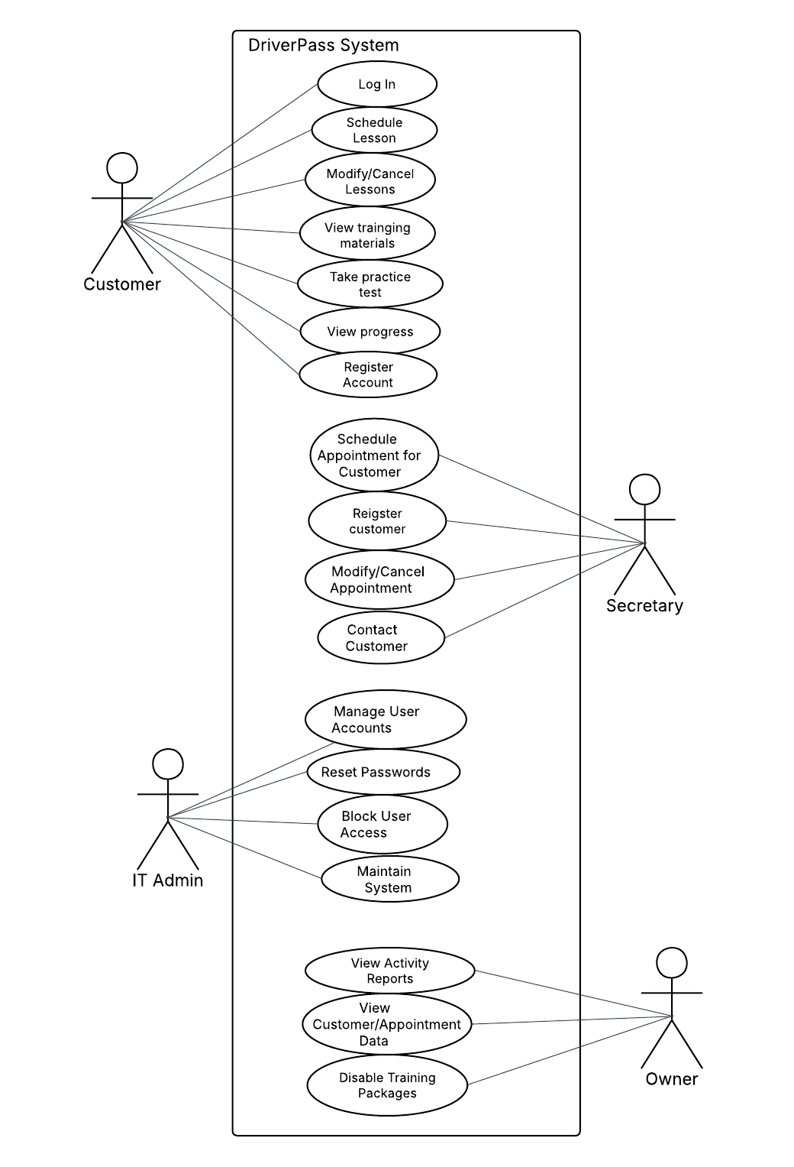

UML Activity Diagrams
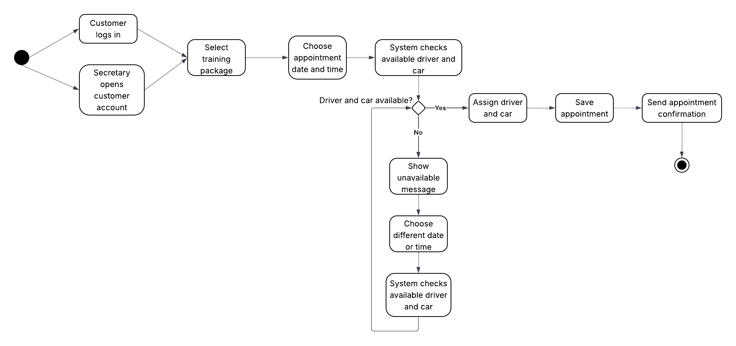
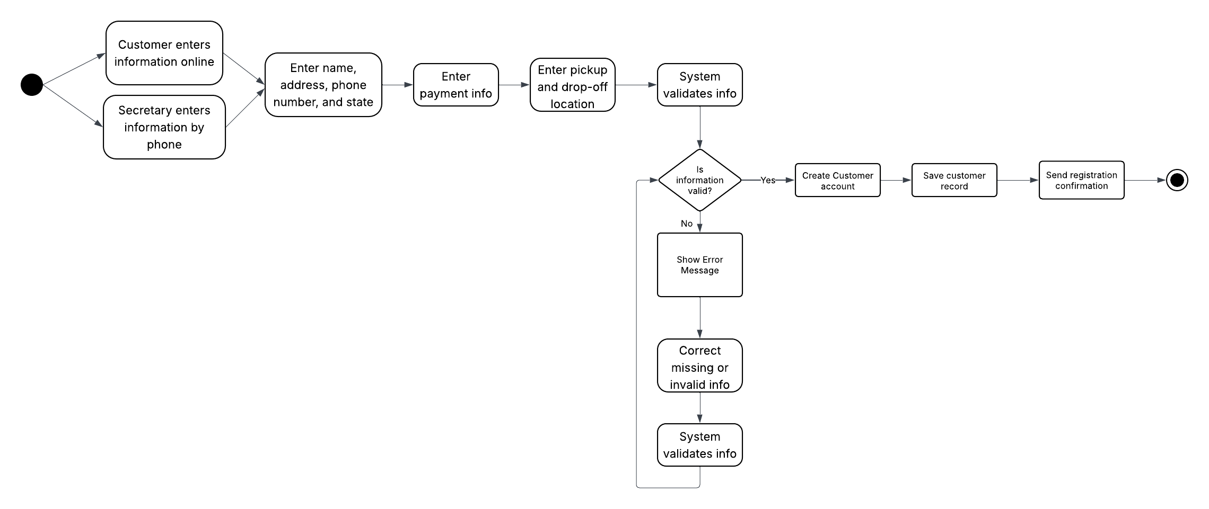

UML Sequence Diagram
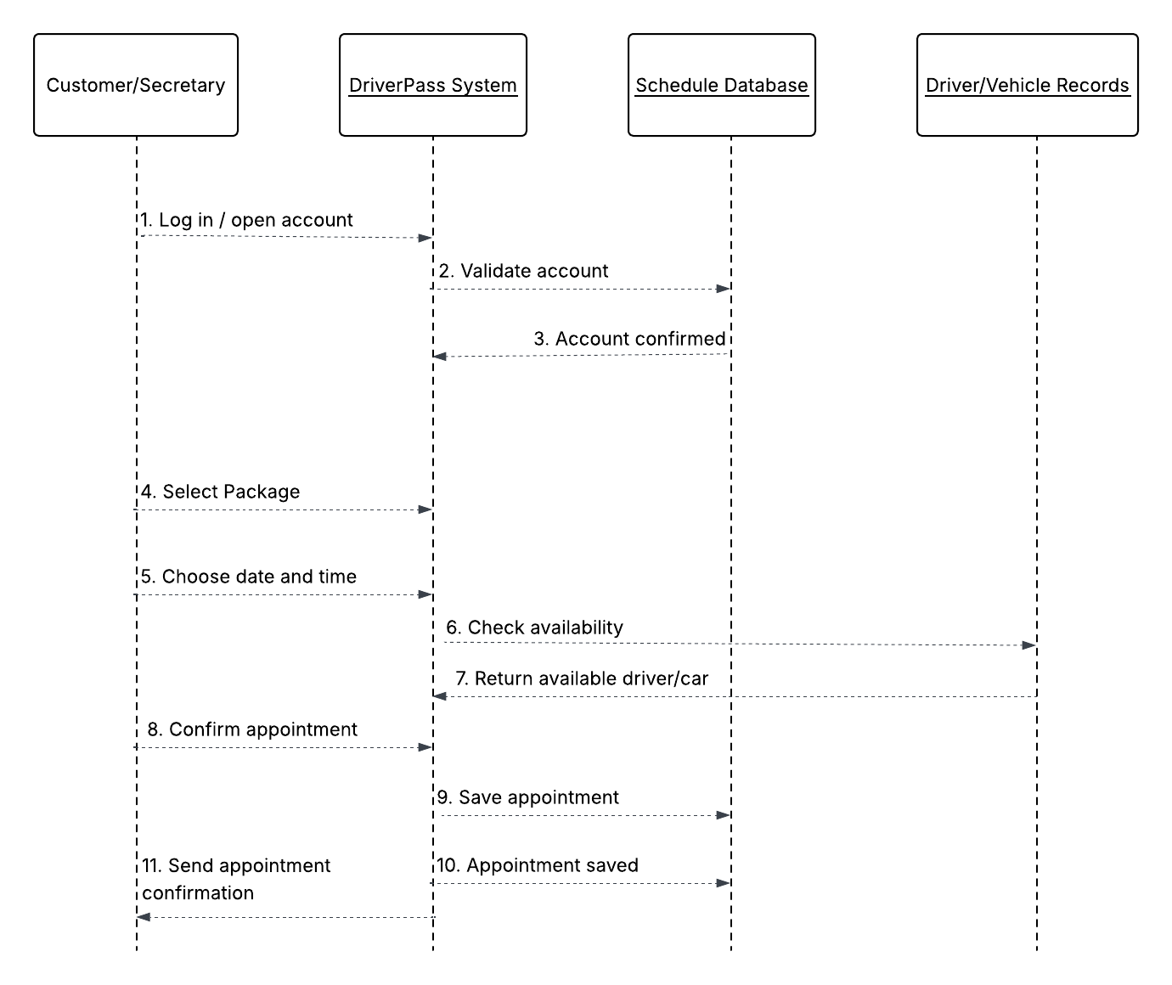

UML Class Diagram
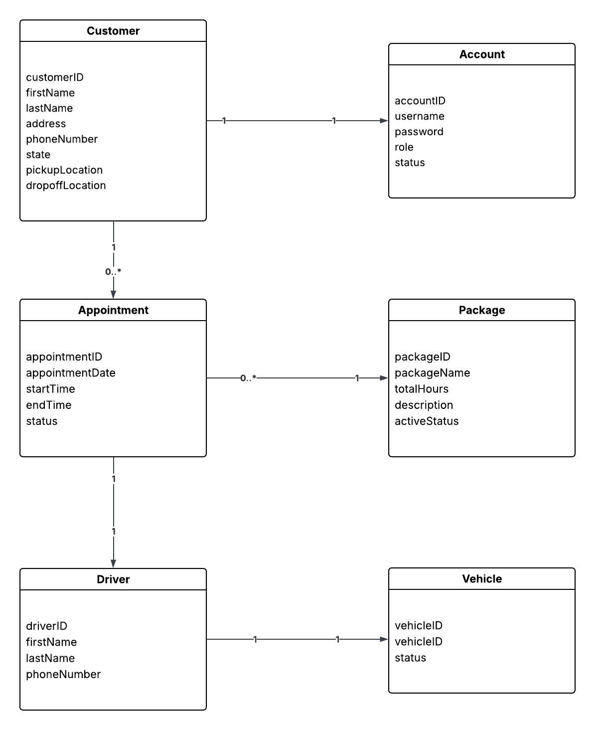

Technical Requirements
Technical Requirements
The DriverPass system will require a combination of hardware, software, tools, and infrastructure to support its functionality. These requirements ensure that the system operates efficiently, securely, and is accessible to all users.

System Architecture
The DriverPass system will be designed as a cloud-based web application. Users will access the system through a web browser, while the backend server will process requests and manage data. The system will follow a client-server architecture and will include a user interface layer, application logic layer, and database layer. This structure allows for scalability, reliability, and ease of maintenance.

Hardware Requirements
- Users will need access to a computer, tablet, or smartphone with internet connectivity.
- Staff members will use office computers to manage customer data and appointments.
- The system will be hosted on cloud-based servers to handle processing and storage needs.

Software Requirements
- A modern web browser such as Google Chrome, Microsoft Edge, or Safari will be required to access the system.
- The backend system may be developed using a programming language such as Java, Python, or Node.js.
- A database management system such as MySQL or PostgreSQL will be used to store and manage data.
- The system will be compatible with multiple operating systems, including Windows, macOS, and mobile operating systems.

Tools and Technologies
- Lucidchart will be used to create UML diagrams for system design.
- A cloud platform such as AWS or Microsoft Azure will be used for hosting the system.
- A secure payment processing service will be integrated to handle customer transactions.
- A version control system such as Git will be used during development to manage code changes.

Infrastructure Requirements
- A reliable internet connection is required for system access and operation.
- Cloud hosting will provide scalability, data storage, and system availability.
- Secure database infrastructure will store customer, appointment, and system data.
- Integration with external systems, such as DMV updates, will ensure that training materials remain current.
Security Requirements
- The system will require user authentication through a username and password.
- Role-based access control will restrict system access based on user roles (customer, secretary, IT administrator, owner).
- Sensitive data, including payment information, will be encrypted to ensure security.
- The system will include password reset functionality for users.
- Activity tracking will log user actions to maintain accountability and system integrity.

